Chowly Integration
Volcora POS
Chowly Integration
Introduction:
This document explains the new integration partner – Chowly Integration.
Requirement:
A new integration partner - Chowly to be included in Back Office to enable Online Ordering Services
Implementation in Back Office:
Page Navigation: Log into My Store >> Settings >> Store >> Integration >> Chowly
- Chowly is a large Online Ordering Platform.
- Chowly has done integrations with many platforms such as Uber Eats, Postmates, Caviar, Grubhub, Captain, Joyup, Bite Squad, EatStreet, Lodel, Order Up, Go Parrot, Doordash, ezcater, Waitr, Ritual, Munchon Eats, Deliver Logic, delivery.com, getkosher.com, iMenu 360, Mealeo, Ordersnapp, Zuppler, MunchAdo, 9Fold, WeDeliverEats.com, DataDreamers, Hungrybuffs, btownmenus, 2nd Kitchen, Caterzen, Snackpass.
- Here, we have already integrated with Urban Pipper and now we have Chowly. With the help of Channel / Aggregator we can be able to distinguish the source of Online Orders.
Menu Publish:
- Stores with Zenpepper License are able to integrate with Chowly to enable Online Ordering across various platforms
- Chowly will create the Store using Location Name, Store Number/ID, Webhook Address, Full Address of the Location, API Key.
- With the help of the API Key, Push the Menu Items to Chowly based on the Items which store wants to publish in Chowly. From Chowly, the particular store and its menu items will be visible in the Online Platforms. Through this, Online Orders takes place.
- If the particular Store has multiple location, then for each location Chowly should be enabled through this tool, a location specific API key will be required.

- Navigate into My Store >> Settings >> Store >> Integration >> Chowly. Here, the below screen will appears
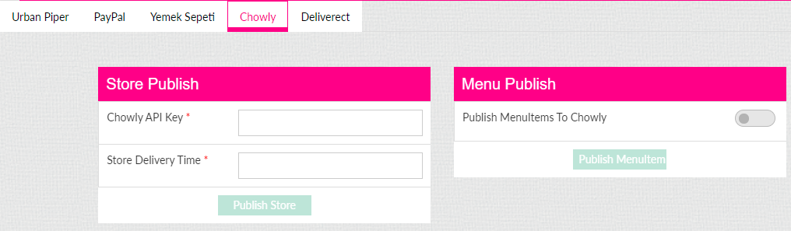
- Here, the text box will be available for entering the API key. This will be unique for each store, and it will be provided by Chowly to the Stores (stores can directly contact Chowly or contact support for API key generation)
- Here, the store user will be able to enter the Store Delivery Time by themselves. Based on this time settings, the customer will get the estimated arrival time for their orders.
- When the toggle Publish Menu Items to Chowly is enabled, you can Push/Publish the Menu Items with other third party online ordering platform by clicking on “Publish Menu Items.”
- When Publish Menu Items is clicked, Zenpepper will automatically fetch the Menu Items and these Menu Items will be reflected in third party online ordering platform through Chowly.
- All the menu items will be published from the Back Office. The menu items tagged to Departments, Category, Subcategory, Taxes, Modifiers, Menu Items will be published in third party online ordering platform.
- If the store wants to Hide Menu Items in Online Ordering, then Navigate into:
My Store >> Products/Items >> Products/Items >> Menu Items >> Hide Menu Item in Online Order
Upon enabling this option Hide Menu Item in Online Order and click on “Update and Publish” button and also click on “Publish Menu Items” in the Chowly integration page then the particular menu item will not be visible in Chowly.
Menu Created and Published in Back Office
Reflects in Chowly
Reflects in Online Ordering Platform

Reflects in Zenpepper

Order Received through Chowly:
- When an online order is received through an Online Ordering Platform, this order will be sent to Chowly and Chowly will push this order to Zenpepper. From Zenpepper it will be received to our iPad and POS. Here, in iPad and POS, the order received, and acceptance takes place and the acknowledgment will be sent to Zenpepper and from Zenpepper the acknowledgment will be sent to Online Ordering Platform through Chowly.

Online Order Received through Online Platform Eg. Uber Eats
Zenpepper
iPad and POS; Order received and accepted.
Order accepted message to the Customer
Acknowledge to Online Ordering Platform

Acknowledge to Chowly

Chowly
Acknowledge to Zenpepper

- Once an online order takes place through the Third Party (Chowly Partners), Chowly will transmit this Online Order to our POS system. The Order Confirms within 30 seconds by the Store.
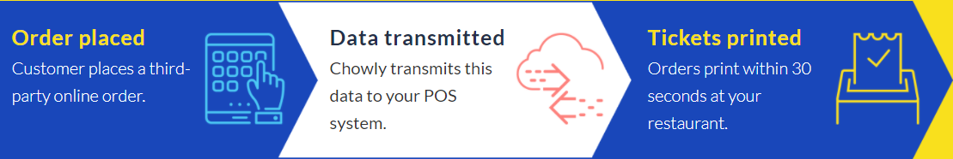

- When Order is received through Chowly, it will be received through Zenpepper. Whenever the Online Order reaches Zenpepper, it will be directly sent to the Kitchen for Preparation and the same order will be in Active Order page in POS simultaneously & estimated time will be sent to online ordering platform via Chowly if the estimated time is configured in the Back Office or Zenpepper admin.

- Future orders are held within the Chowly system until the calculated time (60 mins) required for order preparation before the promised time and it will be directly sent to the Kitchen for Preparation. The same order will be in Active Order page in POS simultaneously.

- Discounts will not be applicable for Chowly. When the user tries to apply discount, message will be displayed saying “You will not be able apply discount for this order since its from online aggregator”

- Since the check cannot be altered in Chowly, the gift card, tax exempt, open item, gratuity options also must be disabled.

- In Chowly, Manual cancellation of the Online Order is not allowed. Here, the Void buttons will be disabled, so Manual Cancellation cannot be done. When the user tries to click on void button for Chowly orders, a message will be displayed “You will not be able to void this order since its from online aggregator”. Only Automatic Online Ordering Cancellation takes place when the POS is offline for more than 20 mins.

- Serving Size: Only one Serving Size will be applicable to one Menu Item. We are not able to add multiple serving size for a single item. If the user wants to add another serving size for a particular menu, then the user needs to create a new Menu Item with another serving size (OR) When menu item has multiple serving sizes, delete those serving sizes for that menu items and make the amount as $0. Then the user will be able to create those serving sizes in the mandatory modifier screen. While creating the modifier the user can be able to give the price of the modifier and this will be displayed when user chooses this item. When menu item has a modifier already, then this cannot take place.

- Sort Menu Config: When user wants to align/sort/order the Categories in the Ordering Platform, then in BO settings the user will be able to choose Sort Menu Config option (Navigation: My Store>> Products/Items>> Sort Menu Config) and can be able to arrange the Categories. The arranged categories will be published in Zenpepper by clicking on Publish Your Menu Changes in POS option, after this click on the Publish Menu Items in Chowly Integration in Store Settings to get displayed in ordering platform. By default, the Categories will be listed in Alphabetical order.

- Available and Restriction Time will not be applicable in Chowly. The timing will be displayed based on the Store Opening and Closing Hours. The Menu Item can be restricted by enabling the toggle Hide Menu Item in Online Order.

- Suspend Until: As per Back Office operations this feature cannot be used for now.

- Modifiers: Below are the modifier changes that need to be made in specific for Chowly integration
- Modifier groups must be unique for mandatory & optional (E.g. Modifier group A cannot be available in both mandatory & optional. It can be either in mandatory or optional)
- The user must be able to add the same modifier to different groups of mandatory modifiers.
- Included Modifiers will not be applicable in Chowly. It is based on the store to decide whether included modifier needs to be an added part of the order or not.
- Minimum & Maximum will be applied to mandatory modifiers. For optional modifiers the minimum will be 0 & maximum will be count of modifiers in that group. E.g. if there are 3 modifiers in modifier group A & 2 modifiers in modifier group B, the maximum quantity will be 5.
- Service Type-Phone order To Go/Delivery (Only for Chowly)
- Whenever any Order (sale) takes place, there will be line item in New tab, Select the Check & then click on the “Edit” option.
- The user will not be able to add menu items once the order is received through Chowly, in case the user tries to edit the order by adding menu item, the system will not allow the user to add the menu item & will display error message “You will not be able modify this order since its from online aggregator”
- User can select Payment, When the payment is made through online payment gateway, then the due balance will be 0 ,the user can click on “Submit” option. This will close the check & the check will be moved to closed tab.
Note: By default, transaction through Cash will be disabled in Chowly. Only Card Payments will be accepted here.

